BEST OUTGOING STUDENTS
NAMES OF THE STUDENTS | BATCH | PHOTO
Ms. VINITHA MONTEIRO | 2007-2011 | 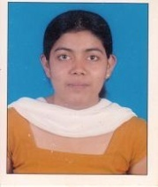
Ms. ANURADHA SHASTRY | 2008-2012
Mr. THOMAS ZACHARIA | 2009-2013 | 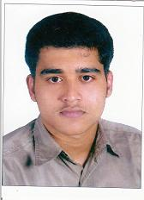
Ms. ANEEKHA VARGHESE | 2010-2014 | 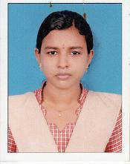
Ms. BETSY S MATHEW | 2011-2015 | 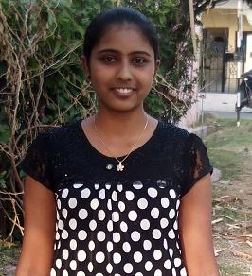
Ms. SRUTHI ELEZABATH JAMES | 2012-2016 | 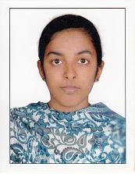
Ms. JOVITA PRIYA TAURO | 2013-2017 | 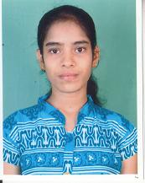
Ms. LAKSHMI S KUNNATH | 2014-2018
Ms. GWENDELEN LAURA DSOUZA | 2015-2019
MS. VIONA MARIAM DSOUZA | 2016-2020
MS. ADLINE PRINCITA DSOUZA | 2017-2021
MS. KESIYA ELSA VARGHESE | 2018-2022

MANGALORE UNIVERSITY RANK HOLDERS
RANK | NAMES OF THE STUDETNS | BATCH | PHOTO
1ST RANK | Ms. ANURADHA SHASTRY | 2008-2012
2ND RANK | Ms. ASWATHI ANNA REJI | 2010-2014 | 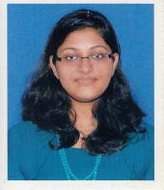
1ST RANK | Ms. ANJU GEORGE | 2011-2015 | 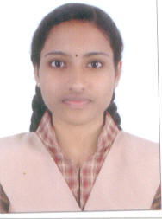
2ND RANK | Ms. BETSY S MATHEW | 2011-2015
3rd RANK | Ms. JOVITA PRIYA TAURO | 2013-2017
3rd RANK | Ms. PRITHVI N | 2015-2019 | 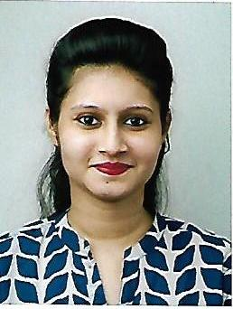
1st Rank | MS. RACHEL ELIZABETH JOHNSON | 2016-2020
1st Rank | MS. ADLINE PRINCITA DSOUZA | 2017-2021
2nd Rank | MS. ALEENA JOSE | 2017-2021 | 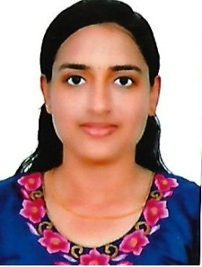
2nd Rank | MS. KESIYA ELSA VARGHESE | 2018-2022 | 